# Worksheet 7a Reading from a file Answers

# The text file people.txt is used in these questions:

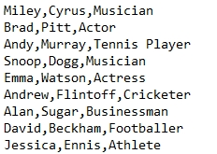

***(See program L7 WS7a Reading a text file.py in Sample programs file)***

1. Use this code to predict which line of the file will be printed.

famousPeople = open("people.txt", "r")  
line = famousPeople.readline()  
line = famousPeople.readline()  
famousPeople.close()  
print(line)

Answer:

Brad,Pitt,Actor

1. Use this code to predict which line of the file will be printed.

famousPeople = open("people.txt", "r")  
for counter in range(6):  
 line = famousPeople.readline()  
famousPeople.close()  
print(line)

Answer:

Andrew,Flintoff,Cricketer

1. Add the statement print(line) somewhere in this program so that it will print out each line from the file, one at a time.

famousPeople = open("people.txt", "r")  
for counter in range(9):  
 line = famousPeople.readline()  
 print(line)  
famousPeople.close()

1. Complete the second line of this program so that it will print Emma Watson’s details.

file = open("people.txt", "r")  
for counter in range(5):  
 line = file.readline()  
file.close()  
print(line)

Now type up the program and test it to see if you were correct.